Marketing cloud admin

1.but no access to any send activities.
Least privilege in mind?
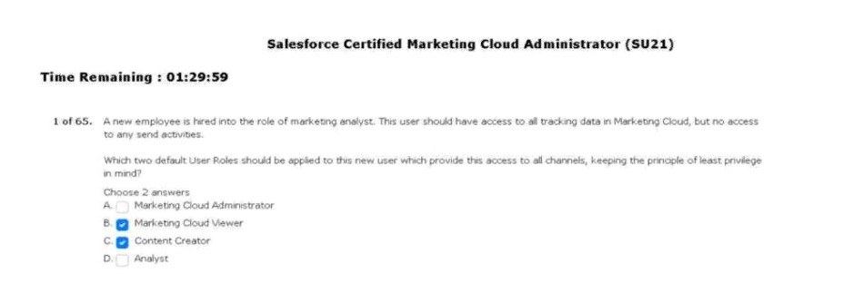
2. to customers during the checkout process.
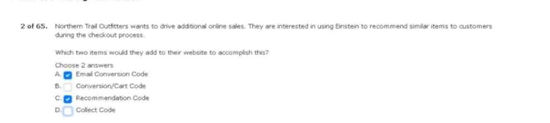
3.receives the following error message.
Looking at the user settings.
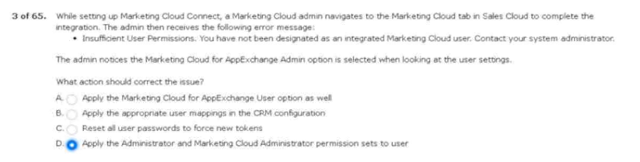

4. issue with their sends today.
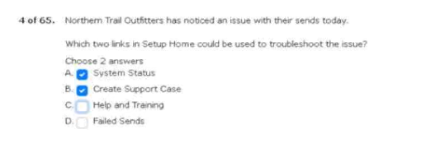
5. emails from any other business unit. 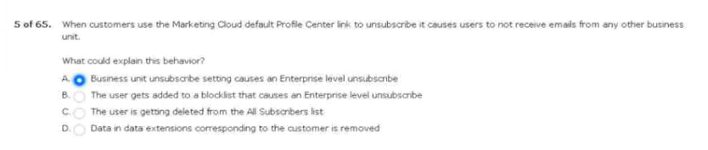
6. many emails were sent in the last week.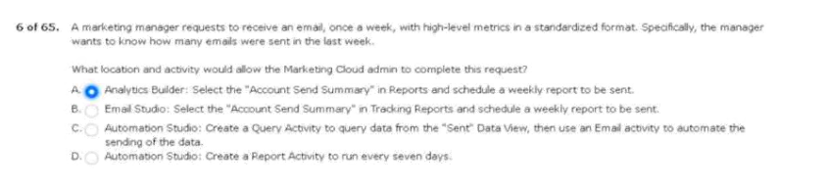
7. within 10 miles of one of their stores.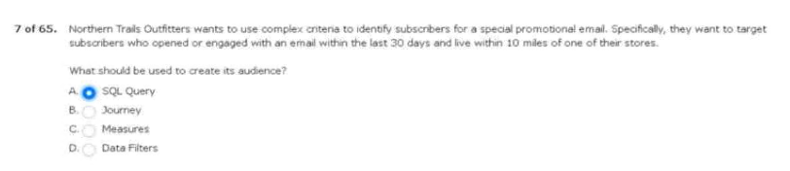

8.purchases to their marketing cloud account.
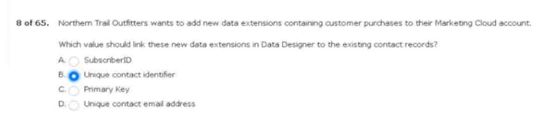
9. contacts which have been sent to remain.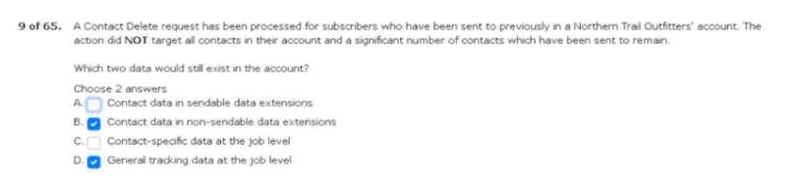
10. view all verified email addresses?
11. and deliver the next-best content?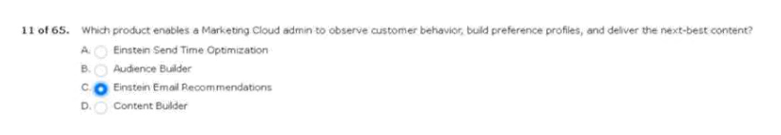
12. when setting up distributed marketing?
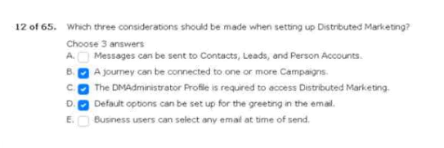
13. identifiable information (pii) within their links.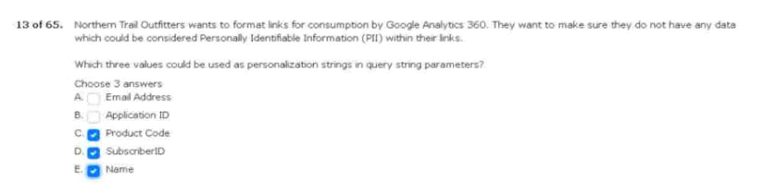
14. email solution to marketing cloud.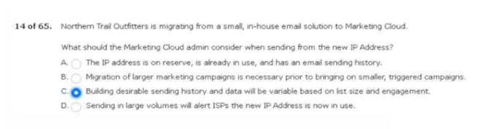
15. data manager, and marketing cloud viewer.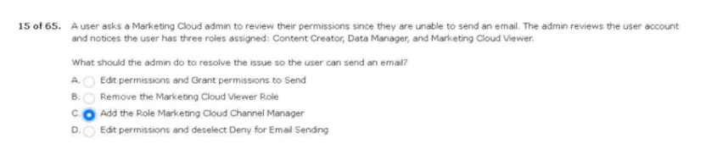
16. api access to their marketing cloud account.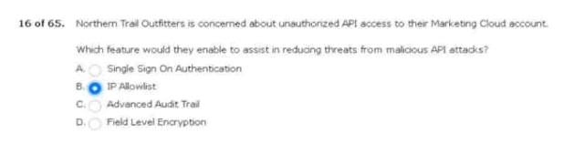
17. to all the links in an email sent via email studio.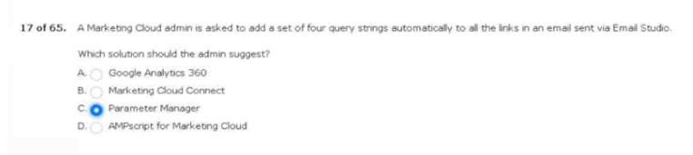
18. cloud connect multi-org enablement.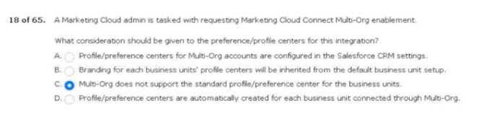
19. data extensions to store user-facing information.
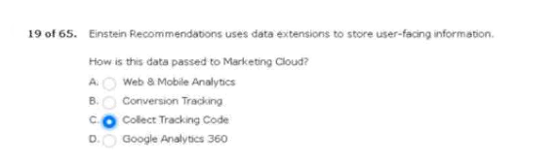
20. across each of their marketing cloud accounts.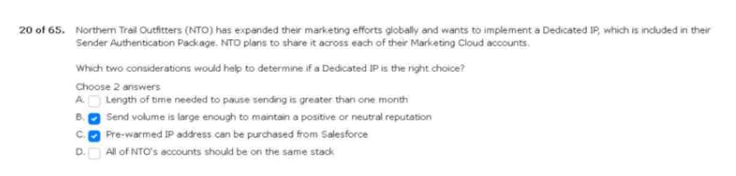
21. copy journeys across business units.
Recreated in another account?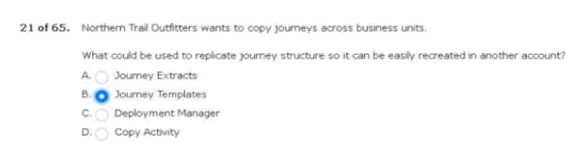
22. for their annual super messages.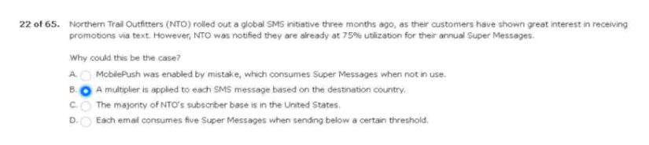
23. monitor deliverability across major isps.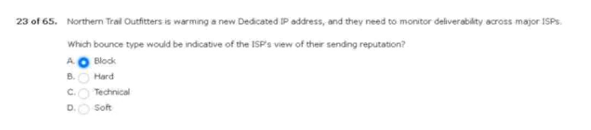
24. content testing within journey builder?
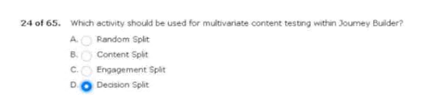
25. area within a triggered send email is performing.
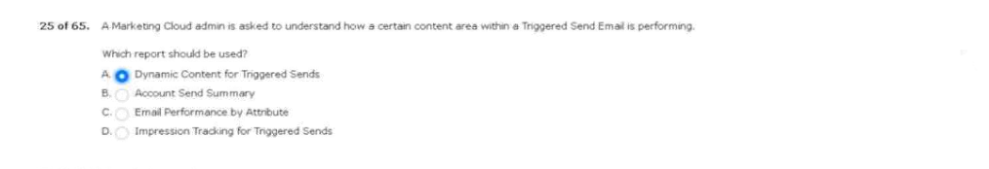
26. for campaigns related to b2b sales.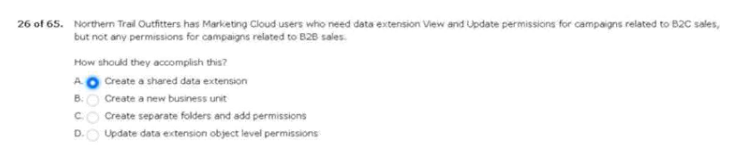
27. winner has been selected.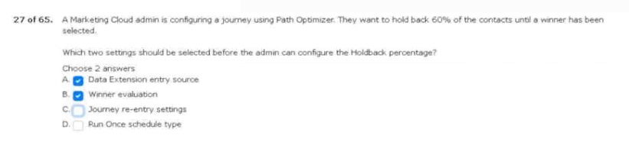
28. cloud connect is functioning properly.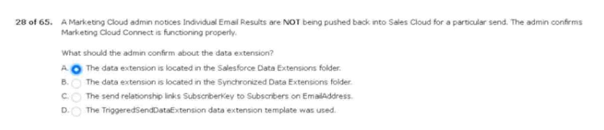
29. since not all contacts will be sent an email.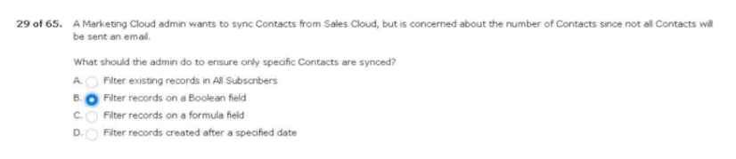
30. variable string to links in emails.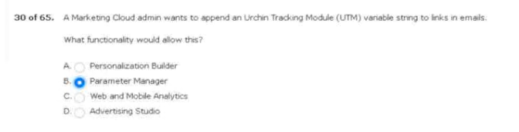
31. to be cleared after 12 months.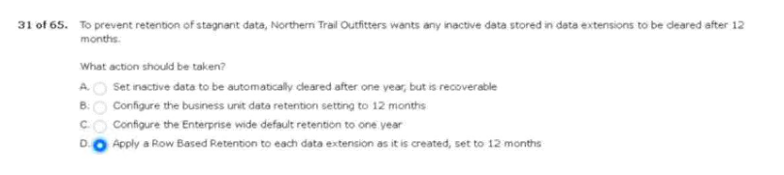
32. file transfer activity to decrypt the file.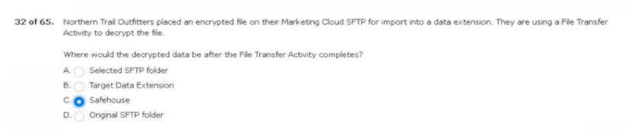
33. sent to marketing cloud to execute a send.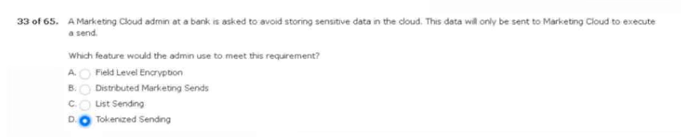

34.social media accounts.
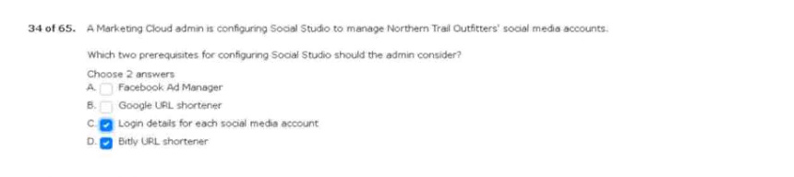
35.reporting they do not have access.
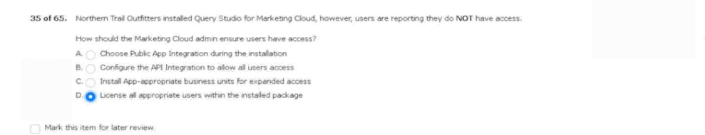
36.units in the last calendar year.
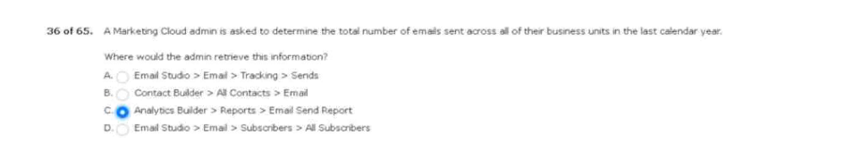

37.push channels in the near future.
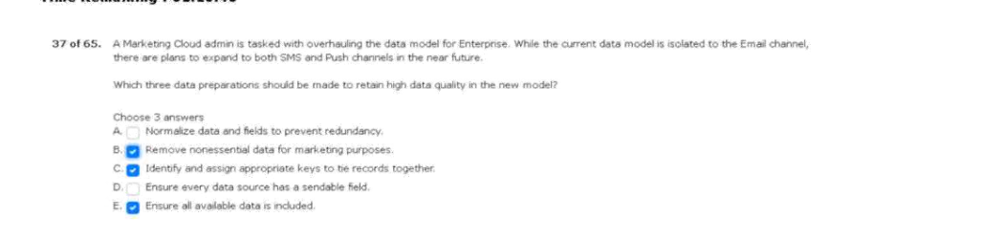
38.recent a/b test send was not recorded.
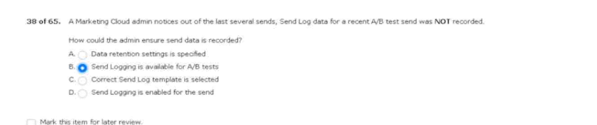

39.and 75000 mobile subscribers.
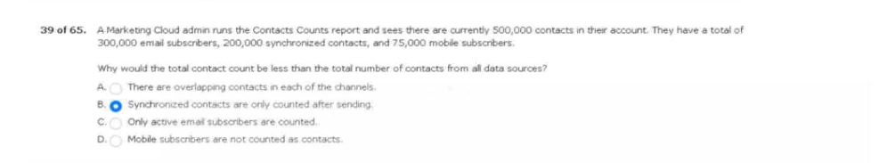
40.for hard-bounced email addresses.
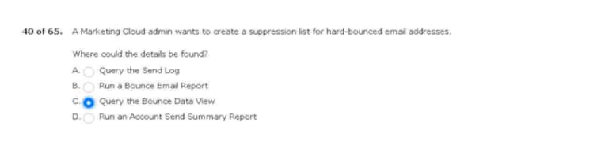

41.asking to be removed from the mailing list.
Take to enable this functionality?
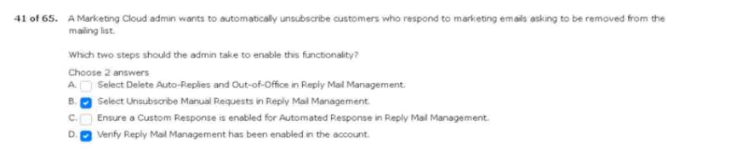
42.based on sales cloud data.
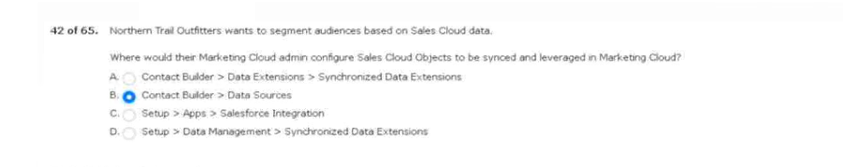
43.send log data extension.


44.without granting access to marketing cloud directly.
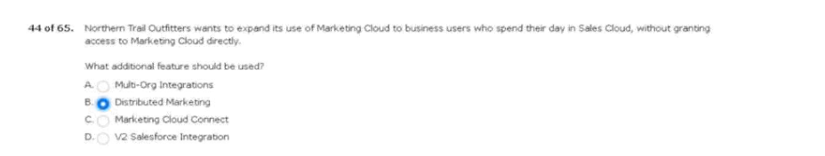

45.the keyword is unavailable.
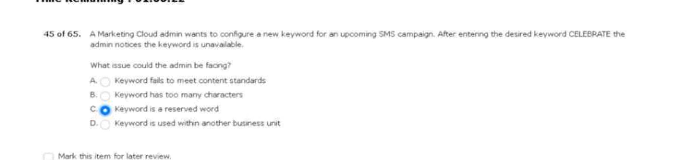
46.based on records in their database.
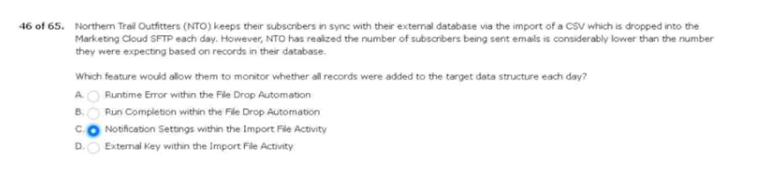
47.email to one million subscribers.
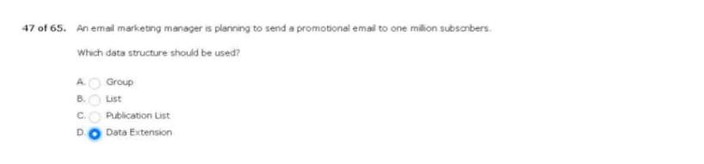
48.update their marketing cloud sftp password.
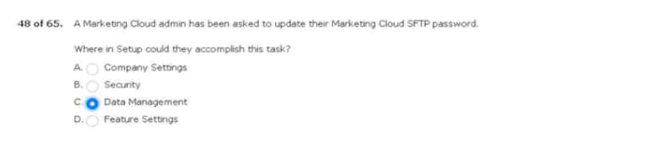

49.any email address associated with their domain
Taken to implement this?
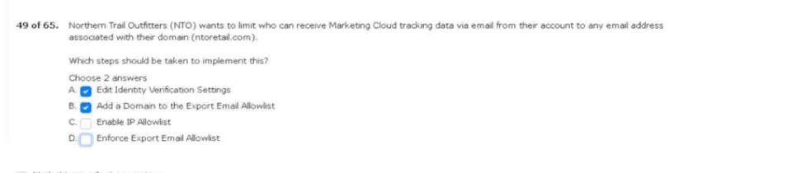
50.manager is out on parental leave.
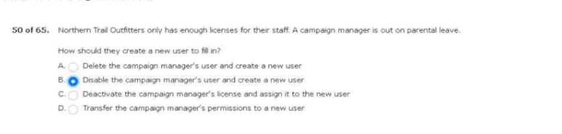
51.assign to the new business units.
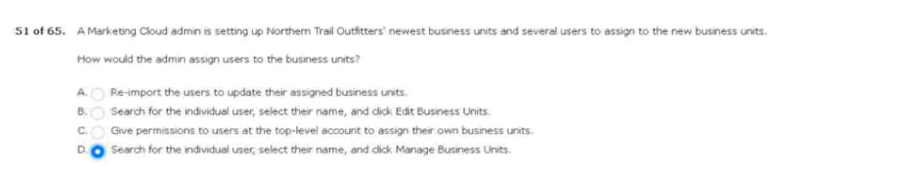
52.has an invalid format.
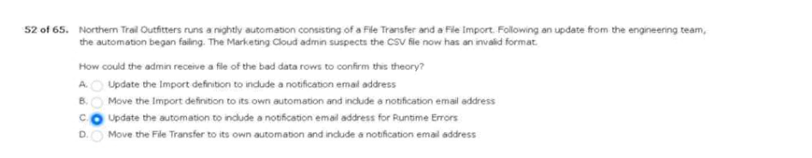
53.still be able to view data within the system.
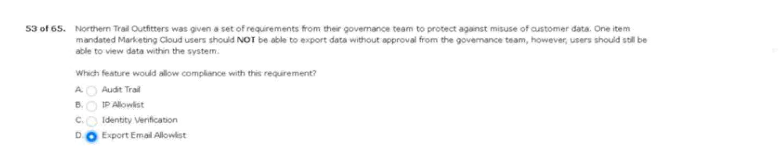

54.when they do large sends.
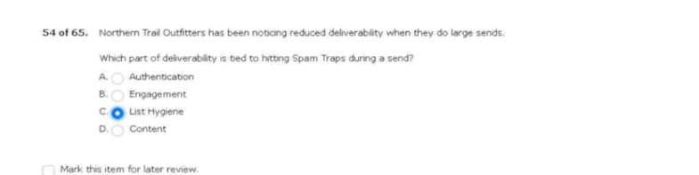
55.made a purchase during this time.
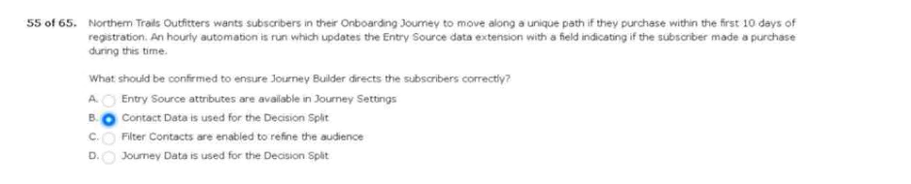
56.roles for their business processes.

57.via marketing cloud connect.
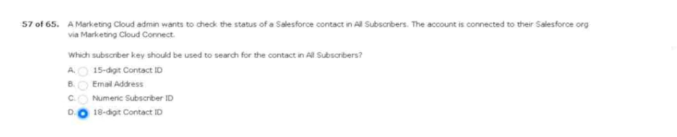
58.they plan to build.
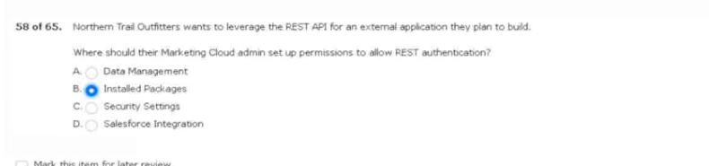

59.marketing cloud user credentials.
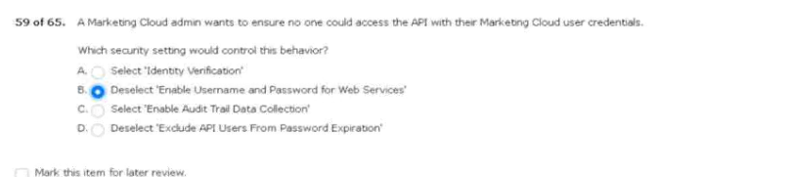
60.online purchase is made.
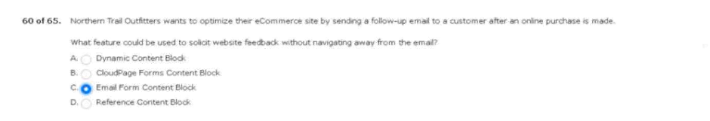
61.could enter a journey?
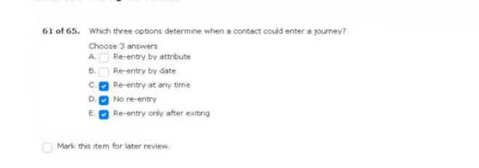
62.new marketing cloud account.
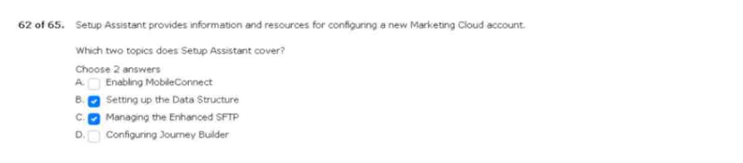

63.permissions to a new user.
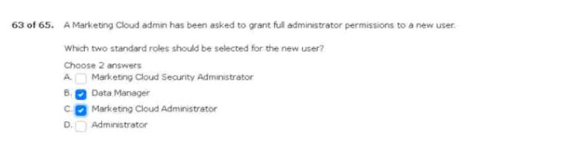
64.out-of -the-box subscription center?

65.had a bounced status in marketing cloud.
